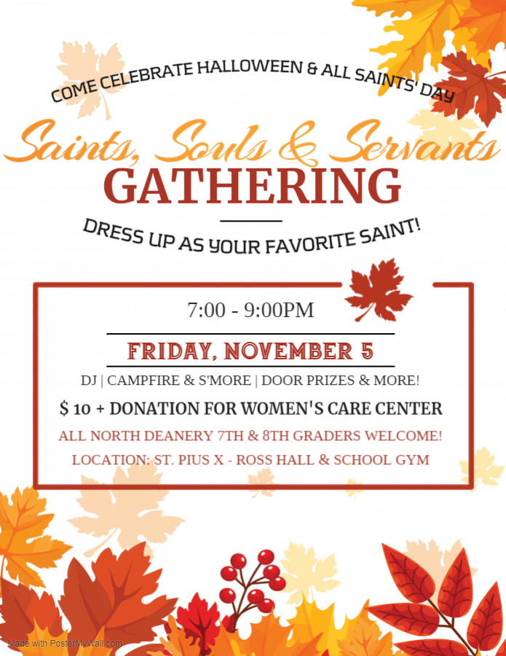
** PLEASE REMEMBER TO BRING A MASK! **
All participants, including guests, must fill out a Permission Form.

I give permission for my daughter / son _____________________________________________ to attend the “Saints, Souls, and Servants Gathering” on Friday, November 5, 2021 from 7-9 pm at St. Pius X Catholic Church. I have read the North Deanery Guidelines on the back of this permission form. In case of emergency, I give permission to the North Deanery Youth Ministers, and/or adult chaperones, to transport my child to the hospital for treatment and contact me as soon as possible.
Parent/Guardian Signature: ____________________________________________________
Contact Numbers (2): ____________________________/____________________________
Parish: __________________________ OR Guest of: _______________________________
Please contact your parish's Youth Minister for further information.
North Deanery Youth Ministry Association
Event Guidelines 2021-2022
The policies listed below are for all North Deanery Junior High events. These are meant to ensure a safe, healthy and Christian environment for North Deanery Youth Ministry Association (NDYMA) events. We appreciate your participation in NDYMA events and your assistance in following these rules!
*Proper Dress Policy: Your attire and dress code should always reflect Christian Modesty, both in how the clothing covers your body and in what your clothing says! Appropriately dressed students will be welcomed and admitted. Appropriate attire is at the discretion of the NDYMA members. When in doubt, please bring alternative attire.
*Electronics Policy: Cell phones are encouraged to be in your pocket, as we want you to enjoy and be unplugged at NDYMA events. Mp3 players; portable gaming devices; iPods; iPads; cameras; etc. are requested to be left at home.
*Entrance and Exit Policy: All attendees must arrive with the NDYMA Permission Form, or a Parent’s Note that includes an emergency phone number and a parent’s signature, prior to admittance. Only those with written parental permission will be allowed to leave early from the event.
*Guest Policy: North Deanery Junior High Students are allowed to bring 1 guest. The guest must arrive with a NDYMA signed Permission Form, as well as a signed Events Guidelines Form. The North Deanery Student and their Guest are to arrive and depart the NDYMA event together.
*Behavior Policy: The purpose of all NDYMA policies is to create a Christian atmosphere and an attitude of consideration and respect for others. Discipline is as fundamental to Catholic education as it is to the Christian way of life. The following behavior is considered inappropriate at NDYMA events: bullying; cheating, lying, or dishonesty; damage or destruction to property; fighting; foul language; groping; inappropriate dancing; kissing; leaving the property without permission; possession or use of any weapon, illegal substances (alcohol, drugs, tobacco, or other); stealing; verbal harassment; and any other behavior or incident deemed to be serious in nature by the NDYMA members.
Displaying any of the above type of behavior will result in parent notification and the student and any guest will be dismissed. Additionally, all involved could face suspension from future NDYMA events.
We, (Parent and Student), are committed to the fun, safe and Christian environment of all North Deanery Events. We have read the above policies and guidelines, and agree to abide by them.
Parent/Guardian Signature: _____________________________ Date: ________
Youth Signature: _____________________________________ Date: ________
Permission to walk: I hereby release and hold North Deanery Youth Ministry Association and their employees, directors, volunteers, and/or others acting on their behalf, harmless from negligence and any and all claims that I or my child may have arising from walking to the event and/or home from the event host site.
Parent/Guardian Signature: _____________________________ Date: ________

